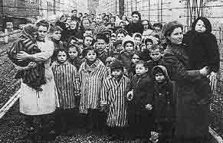
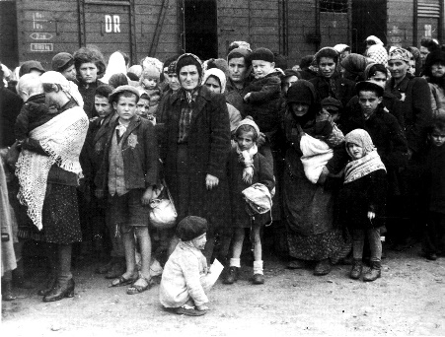
Holocaust

The Holocaust was a terrible and tragic time in modern history during which millions of people were systematically destroyed by Adolf Hitler and his Nazi regime. These people were targeted by the Nazis because of their beliefs, background, heritage, and/or their lifestyle. During this virtual assignment, you will need to log notes about your learning. Let’s begin the step by step process:

Save this document and your progress as you go along. You may type right into the gray text boxes starting at the arrows (>>). Your teacher may ask you to print out this page so you can show what you learned.

- Begin your tour by reading the first paragraph of this brief article: Holocaust.
During what major war did the Holocaust occur?
>>
What types of people did Hitler kill?
>>

- Let’s find out why the Holocaust happened. Scroll down to the “Why Did Hitler and the Nazis do it?” section. Use that paragraph to answer the following questions.
What were some of the main reasons Hitler decided to kill Jews?
>>

What disturbing message did Hitler write in his book, “Mein Kampf”?
>>
What were two things that Hitler did as soon as he became Chancellor?
>>

- Have you ever heard of a ghetto? Read about them in the paragraph called “Ghettos.”
Describe what living in a ghetto would be like.
>>

What happened to Jews that were sent to concentration camps?
>>

- Read more about concentration camps to get some insight on what it is like to live there.

- To answer the questions below, read from the section “Hiding.”
TRUE or FALSE (Write T or F on each line.)

>> __Jewish families would hide with other Jewish families

>> __ Jews would pretend to be part of the family they were hiding with

>> __Some Jews were able to escape across the border

- Now we’ll move on to stories of Heroes. Read each of the sections about the heroes to answer the questions below.
What are the three heroes/stories that were described and why are they so important?
>>

- One of the stories that you read about was Anne Frank. Anne Frank hid in an annex for two years before she was found by the Nazis. Look around on this website and “step inside” the different rooms to find more information about them. Have fun!

For the following questions, you will be getting into more details about the Holocaust.
- Lets learn about how Hitler came to power. Read the first part of this article to answer the questions below.
Why was the mood grim in Germany in the 1930’s?
>>

What percent of the vote did the Nazi party get in 1924?
>>
What percent of the vote did the Nazi party get in 1932?
>>

- Let’s read about how the Nazi terror began.
What are two rights that individuals lost in Germany under the Nazis? Why?
>>

- Read about the SS Police State
What are the SS?
>>

Who created/led them?
>>
What did Dachau become the ideal model for?
>>

- View this page on Nazi Propaganda and Censorship and fill our the questions below.
What did the Nazis do to any viewpoint they felt threatened by?
>>
Who was the Nazi Propaganda Minister?
>>
What types of books were burned by the Nazis starting in 1933?
>>

- Racism, a big problem today, was even worse during the Holocaust. Let’s read some more about Nazi racism.
What was the Germanic race called?
>>
What was said that the ideal person looked like?
>>
Explain how the Nazis began to put their racial ideology into practice.
>>

- Read about some Jews in Prewar Germany and fill in the blanks.
____ Jews lived in Germany in 1933.
(number)

Jews were ____ ____ ____ percent of the Germany population which consisted of 67 million people.

- Read about Jewish life in Europe before the Holocaust.
How many Jews lived in areas that would be occupied by Germany during World War II?
>>
What percent of the Jewish population would be dead in these occupied countries by the end of the war?
>>

- Read this article about Antisemitism.
What is Antisemitism?
>>
For centuries, the church taught that Jews were responsible for _____ death.

- Have you ever heard of the Nuremberg Race laws? Read about them!
What did the Nuremberg Race Laws do?
>>

- Click HERE to find out what the “Final Solution” was.
True or False?
__The Final Solution happened in stages.

The six extermination camps were: __________, __________, __________, __________, __________, and __________.

- Do you know about Auschwitz? Let’s find out more.
How many people died at Auschwitz?
>>
Why type of experiments did Dr. Josef Mengele perform on people?
>>
Who were his typical victims?
>>

- Jews were ultimately liberated.
What happened to half of the survivors at Auschwitz within a few days of being freed? Why did that happen?
>> .

- Lets take a break from reading and watch a quick video from an interview with a survivor of the Holocaust!

Complete the following statements about Ruth Cohen.

When Ruth was __ years old she was taken to a concentration camp called ________.

Some of the people Ruth became friends with were very _________.

Ruth hopes her _________ will remember her personally.

- When people in concentration camps got rescued it was a big part of the Holocaust. Read about it!
Is this statement true or false? (write T or F)

__There was no one who tried to help save some of the Jews.

